A Name

MAC 2311 TEST 1 January 28, 2014

**Calculator Allowed** Work each of the following problems in the space provided. Show all work for full credit.

1. Using a calculated table of values, find . Show the table and the limit.

|  |  |  |  |  |  |  |  |  |
| --- | --- | --- | --- | --- | --- | --- | --- | --- |
|  |  |  |  |  |  |  |  |  |
|  |  |  |  |  |  |  |  |  |

 =

2. If a cannon ball is shot upward from a cannon, its height in meters after t seconds is given by .

a) Find the average velocity of the cannonball for the time period beginning when t = 2 and lasting 2 seconds. Be sure to include units on your answer.

b) Estimate the instantaneous rate of change at t = 2 seconds. Show your calculations. There are several ways to solve this problem.

3. If and , find  and simplify.

4. If  for . Use the Squeeze Theorem to find . Show all steps. Be sure to use correct mathematical notation.

5. If ,

a) evaluate the difference quotient .

b) Find . You can use your result from (a).

6. Write the equation of a line that has a slope of  and goes through the point (-1, 4).

7. Using algebra, a table or the limit rules, find the following limits. If a limit does not exist, explain why. Be sure to show all work for full credit.

a. 

b. 

c. 

8.

|  |  |
| --- | --- |
| For the graph of f(x) below, | 1. on what interval(s) is f(x) continuous? 2. What is the domain of f(x)? 3. What is f(1)? |

A Name

MAC 2311 TEST 1 January 28, 2014

**No Calculator** Calculators are not allowed on this portion of the test. Show all work for full credit. When you are finished with this part of the exam, you may trade back for the calculator allowed part if there is time remaining in the class.

1. If  and  and , find:

(a) 

(b) 

(c) 

(d) 

2. If write functions f(x) and g(x) so that .

f(x) = _____________ g(x) = ____________

3. Evaluate the limits. Show your work for full credit.

a) 

b) 

4. O’HaganBooks.com CEO John O’Hagan has terrible luck with stocks. The following graph shows the value of Fly-By-Night Airlines stock that he bought acting on a “hot tip” from a friend:

P(t)

|  |  |
| --- | --- |
| $30  $25  $20  $15  $10  $5    t  O’Hagan sells  0 1 2 3 4 5 6 7 8 9  O’Hagan buys | a. P(3) =  b.  =  c.  =  d.  =   1. Does  exist? Explain. 2. Is P(t) continuous at t = 3? Why or why not? |

5. What type of discontinuity do the following functions have at x = 4? If it is a removable discontinuity, find a function g(x) that agrees with f(x) for x**≠** 4 and is continuous at x = 4.

a) 

b) 

1. Sketch a graph of a function that has a jump discontinuity at x = 3 and an infinite discontinuity at x = -2.

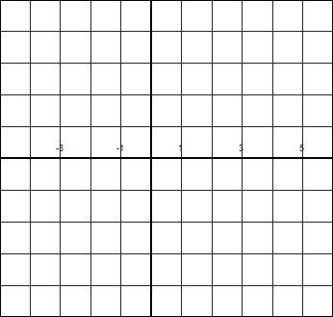

7. Given the graph of f(x) as shown, sketch on the same axis

|  |  |
| --- | --- |
| (a) f(x+2) |  |
| (b) - f(x) - 3 |  |